 

1. **Connect to the Store Sales Data and do the following: -**

− Remove all the blank rows.

− Update the column header if they are not updated

− Create a text table and show the sales in terms of

* 1. o Customers
  2. o Product Category
  3. o Regions

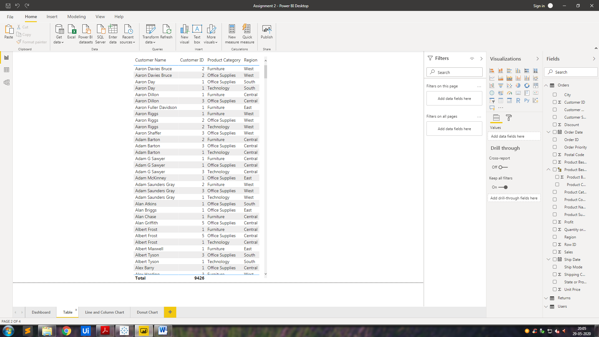

**2. Create a line and Clustered Column Chart showing the Sales and Discount as per the State or Province**

− Format the bars and line with different colors

− Which state has the highest sales in terms Technology

Line Chart

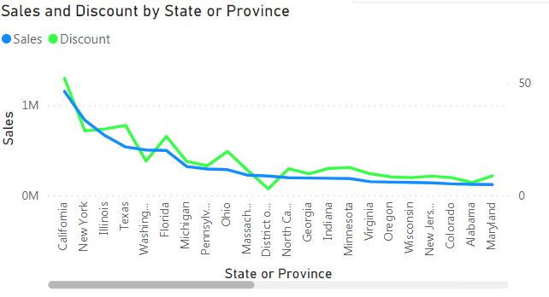

Clustered Column Chart

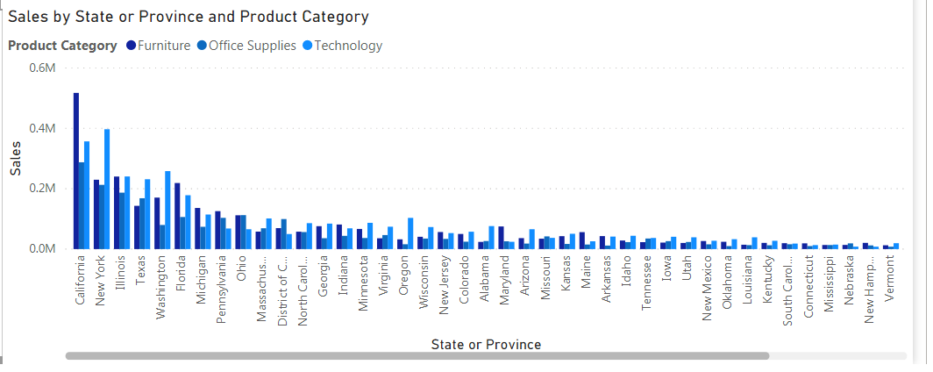

3. **Create a Donut Chart****showing sales in terms of Product category.**

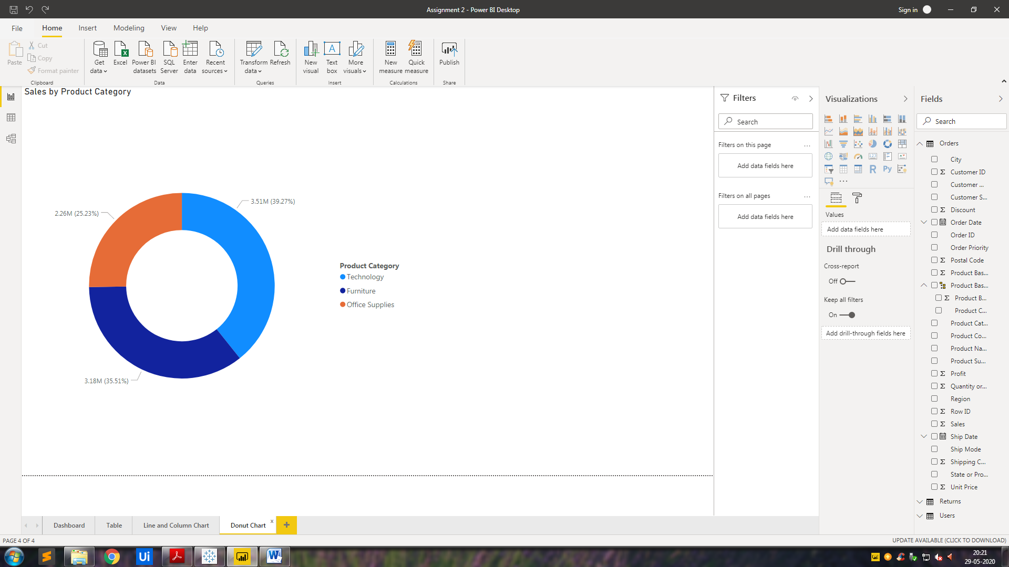

4. **Create a Slicer****and show the regions in dropdown.**

**See how all the visuals mentioned above behaving when a particular region is selected.**

**Slicer** (as per dropdown)

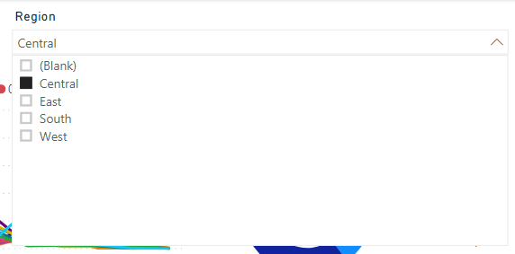

Combined Dashboard

Main Page

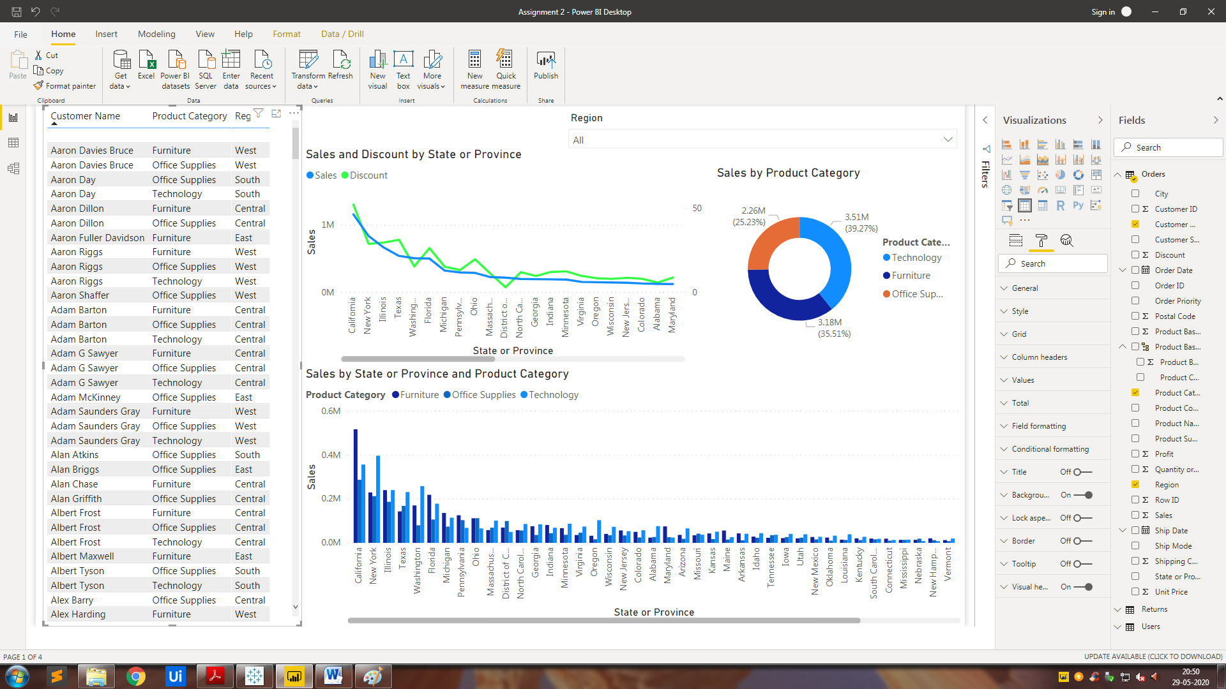

Slicer Changed To Central

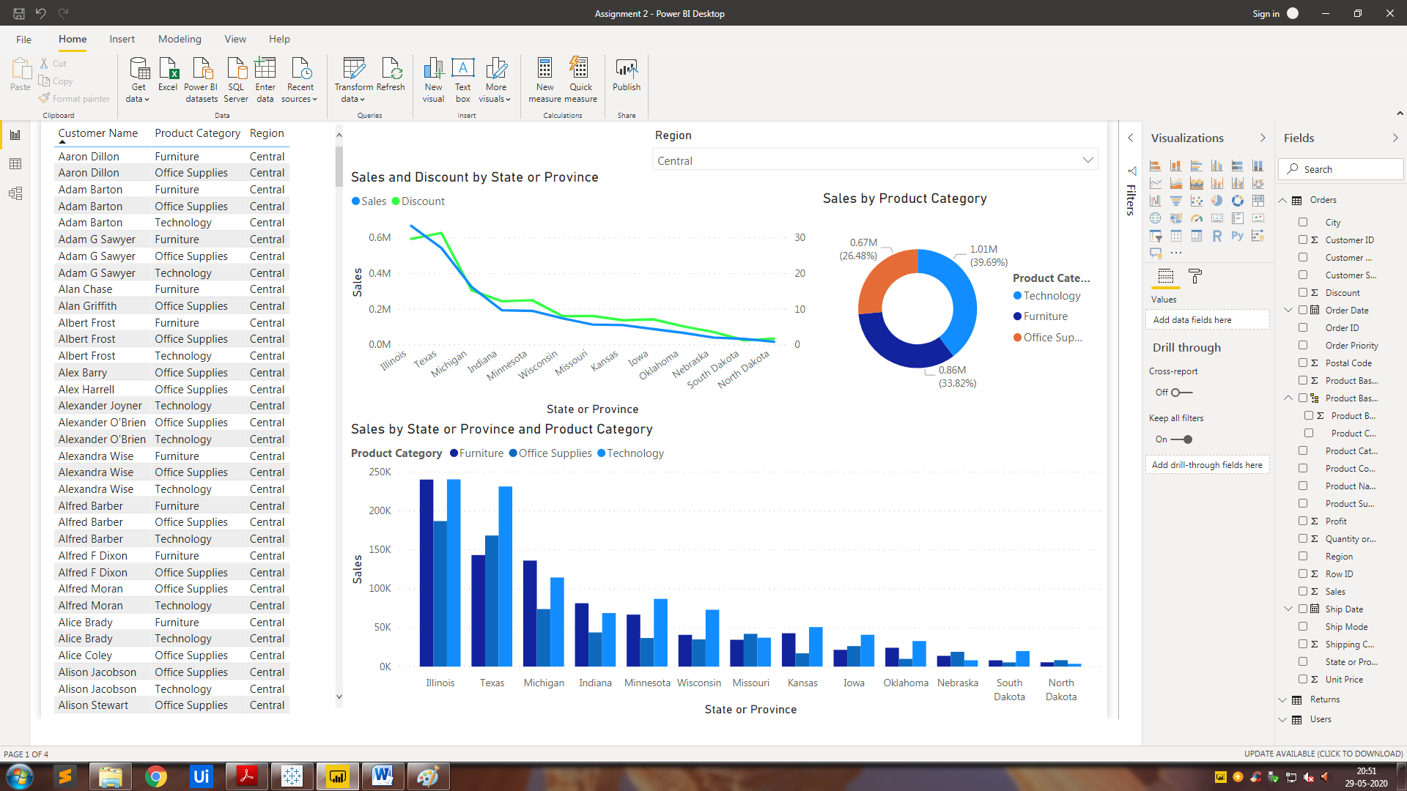

Slicer Changed To South

